## basics

REPL

Read Eval Print Loop

file

execute the file

### comments

# single line comments

""" """ used as multi line comments

## Data Types

* need not be mentioned
* auto evaluated & assigned

int integer

float floating point

str strings

complex

4 + 7i

4 + 7j

### bool

True

False

False:

0

0.0

""

''

[ ]

{ }

## Functions

### general

print

type

input

eval

### sequence

len

sorted

min

max

sum

### cast

int

float

str

complex

list

set

tuple

## Operators

### arithmetic

+

-

*

/

%

// floor division

** power

= assignment

### logical

and

or

not

### relational (conditional)

<

>

<=

>=

==

!=

### compound

=+

…

…

### identity

is

is not

### membership

in

not in

## strings

text

index

negative indexing

IndexError (out of range)

slicing

upper index not included

no range errors

step

| h | o | c | k | e | y |
| --- | --- | --- | --- | --- | --- |
| 0 | 1 | 2 | 3 | 4 | 5 |
| -6 | -5 | -4 | -3 | -2 | -1 |

immutable

functions

lower, upper, capitalize, title

index, count, rindex

replace

### escape sequences:

\n new line

\t tab space

\b back space

\r return

\v vertical tab

\\ \

## list

list of anything (any data type)

duplicate elements allowed

index

negative indexing

IndexError (out of range)

slicing

upper index not included

no range errors

step

mutable

nesting

functions: remove, pop, clear

count, index

reverse, sort

append, extend, insert

## tuple

list of anything (any data type)

duplicate elements allowed

index

negative indexing

IndexError (out of range)

slicing

upper index not included

no range errors

step

immutable

nesting

functions: count, index

## set

only unique

unordered

indexing not possible

mutable

members: immutable

no nesting

functions: … …

… ...

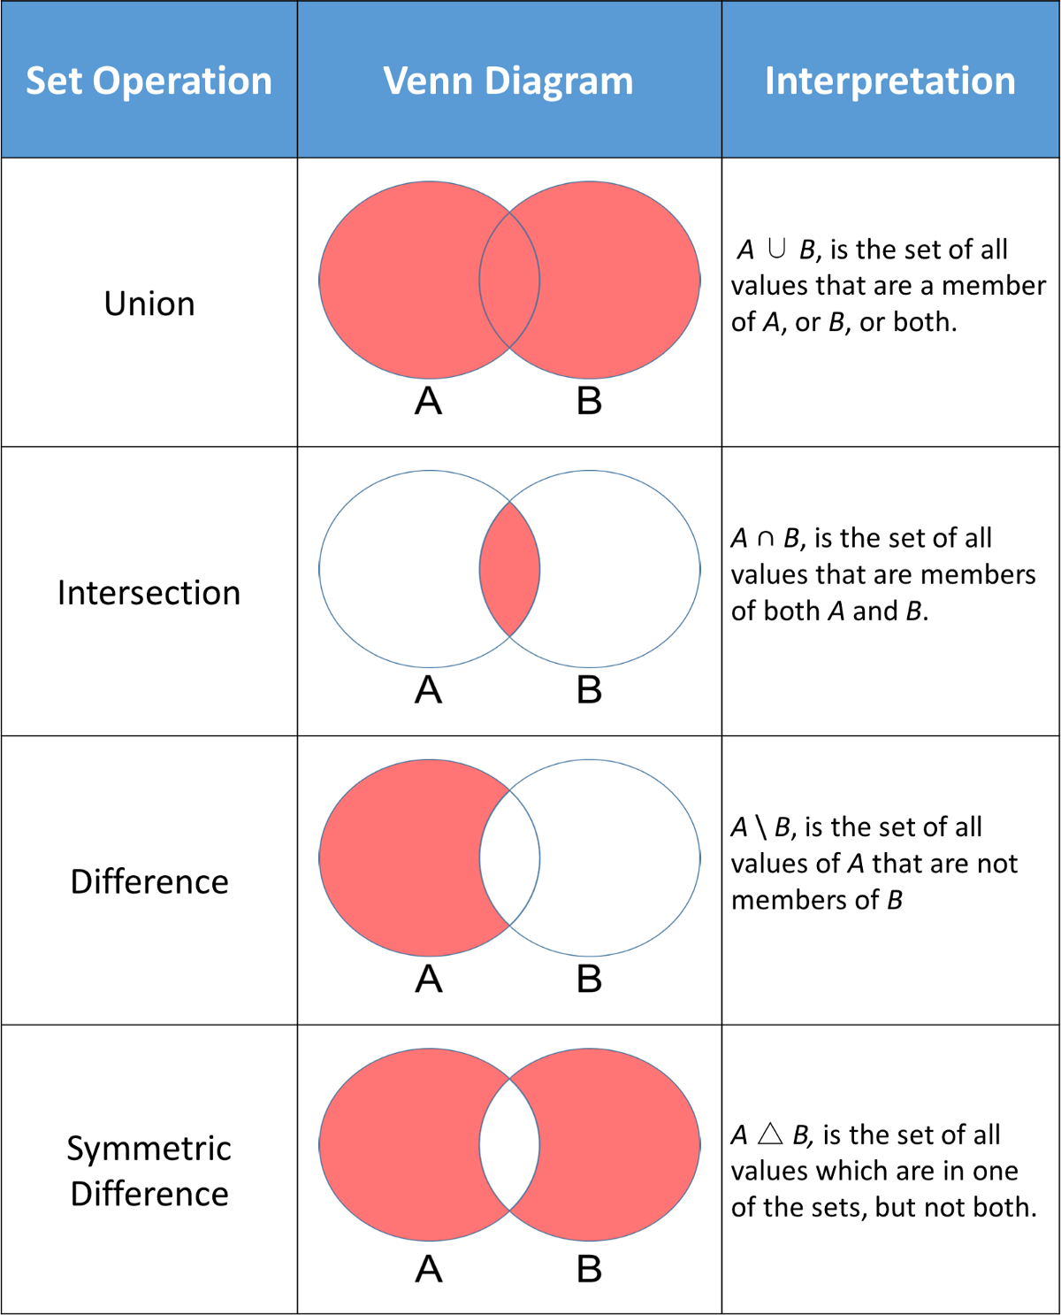

## dict

key: value pair

unordered (3.6 before)

ordered (3.7+)

indices: keys

keys:

immutable

unique

values:

anything

mutable

functions: values, keys

## flow control

### if-else

if

elif

else

### while

### for

break

continue